

Ecosystem infrastructure for smart and personalised inclusion   
and PROSPERITY for ALL stakeholders

Runtime Environment Final Prototype

|  |  |
| --- | --- |
| Project Acronym | **Prosperity4All** |
| Grant Agreement number | **FP7-610510** |
|  |  |
| Work package number | **WP203** |
| Work package title | **Collaborative development tools/Environments**  **T203.3 Runtime Environment** |
| Authors | **Christos Mettouris, Marios Komodromos, Achilleas Achilleos (UCY), Lukas Smirek (HDM), Daniel Ziegler (FHG)** |
| Status | **Draft/Final** |
| Dissemination Level | **Public/Consortium** |
| Delivery Date | **11/07/2016** |
| Number of Pages | **47** |

Keyword List

Runtime, Integration, AsTeRICS Runtime Environment, ARE, URC, UCH, MyUI, REST, URC-HTTP protocol, SSE events, Use Cases

Version History

|  |  |  |  |  |
| --- | --- | --- | --- | --- |
| Revision | Date | Author | Organisation | Description |
| 1 | 12/06/2016 | Christos Mettouris | UCY | Initial authoring (v1) |
| 2 | 06/07/2016 | Christos Mettouris | UCY | Authoring of v2 |
| 3 | 07/07/2016 | Daniel Ziegler | FHG | Authoring/updating of MyUI and Integration Sections |
| 4 | 08/07/2016 | Lukas Smirek | HDM | Authoring/updating of UCH and Integration Sections |
| 5 | 08/07/2016 | Christos Mettouris, Marios Komodromos | UCY | Authoring of v3 |
| 6 | 11/07/2016 | Achilleas Achilleos, Christos Mettouris | UCY | Final updates |
|  |  |  |  |  |
|  |  |  |  |  |
|  |  |  |  |  |
|  |  |  |  |  |
|  |  |  |  |  |
|  |  |  |  |  |
|  |  |  |  |  |
|  |  |  |  |  |

Table of Contents

[Executive Summary 1](#_Toc455742548)

[1 Aim of the document 2](#_Toc455742549)

[2 The AsTeRICS Framework Architecture 4](#_Toc455742550)

[2.1 Aim 4](#_Toc455742551)

[2.2 Background 4](#_Toc455742552)

[2.3 The Original AsTeRICS Architecture 5](#_Toc455742553)

[2.4 Architectural Updates and Developments to the AsTeRICS Architecture: Rest Services 7](#_Toc455742554)

[3 Universal Remote Console (URC) 11](#_Toc455742555)

[3.1 Aim 11](#_Toc455742556)

[3.2 Background 11](#_Toc455742557)

[3.3 Original architecture 12](#_Toc455742558)

[3.3.1 ISO/IEC 24752 compliant communication 12](#_Toc455742559)

[3.3.2 Enabling none-standard compliant communication via the Universal Control Hub 13](#_Toc455742560)

[3.3.3 URC-HTTP Protocol 15](#_Toc455742561)

[3.4 Updates of the URC Architecture 16](#_Toc455742562)

[4 MyUI 17](#_Toc455742563)

[4.1 Aim 17](#_Toc455742564)

[4.2 Background 17](#_Toc455742565)

[4.2.1 Adaption mechanism 17](#_Toc455742566)

[4.2.2 MyUI components 19](#_Toc455742567)

[4.3 Original architecture 20](#_Toc455742568)

[4.4 Updates to the MyUI Architecture 21](#_Toc455742569)

[5 Integration of AsTeRICS, URC and MyUI platforms 23](#_Toc455742570)

[5.1 Integration Schema 24](#_Toc455742571)

[5.2 RESTful based communication between the AsTeRICS ARE and the other platforms 25](#_Toc455742572)

[5.3 Integration of ARE and UCH (Cross Component Communication) 27](#_Toc455742573)

[5.4 Integration of MyUI and UCH 28](#_Toc455742574)

[5.5 Integration of MyUI and ARE 29](#_Toc455742575)

[5.6 Communication Routes between AsTeRICS ARE, MyUI and URC 31](#_Toc455742576)

[5.6.1 ARE → MyUI → URC 31](#_Toc455742577)

[5.6.2 MyUI → ARE → URC 31](#_Toc455742578)

[6 Use Case Scenario: Assisted Living 33](#_Toc455742579)

[6.1 Personas 33](#_Toc455742580)

[6.2 Environment/Available Technology 34](#_Toc455742581)

[6.3 Personalized Technology Control 34](#_Toc455742582)

[Room parameter control 35](#_Toc455742583)

[6.4 Scenario Description 35](#_Toc455742584)

[6.5 Components, Tasks and Roles 36](#_Toc455742585)

[6.5.1 ARE → MyUI → URC 36](#_Toc455742586)

[6.5.2 MyUI → ARE → URC 38](#_Toc455742587)

[7 References 40](#_Toc455742588)

List of Figures

[Figure 1: The original AsTeRICS architecture 6](file:///C:\Users\UCY-PC2\Chris\myceid\!douleia%20pan%20kiprou\douleia\Projects\Prosperity\!Development\!D203.1\D203.1\v3\P4All-D203.1-Runtime%20Environment%20Final%20Prototype_v3.docx#_Toc455760782)

[Figure 2: An OSGi-oriented overview of the ARE architecture 7](#_Toc455760783)

[Figure 3: The REST enabled ARE architecture 9](#_Toc455760784)

[Figure 4: “ARE Status Service” and REST Services Architecture 10](#_Toc455760785)

[Figure 5: The Universal Control Hub (UCH) Architecture 15](#_Toc455760786)

[Figure 6: Overview on MyUI approach to adaptive User Interfaces 18](#_Toc455760787)

[Figure 7: Schematic diagram of the main components of the MyUI infrastructure 19](#_Toc455760788)

[Figure 8: Package diagram of the MyUI cakePHP solution 21](#_Toc455760789)

[Figure 9: Implementation structure of the MyUI Runtime 22](#_Toc455760790)

[Figure 10: The 3 main platforms under the GPII 24](#_Toc455760791)

[Figure 11: Final integration Schema 25](#_Toc455760792)

[Figure 12: Integration of the 3 platforms: AsTeRICS, URC and MyUI 27](#_Toc455760793)

[Figure 13: Local network example 28](#_Toc455760794)

[Figure 14: Services for the integration of MyUI with URC and AsTeRICS 29](#_Toc455760795)

[Figure 15: General communication flow for MyUI patterns containing AsTeRICS models 31](#_Toc455760796)

[Figure 16: MyUI increased button size UI for usage with the AsTeRICS headmouse model 37](#_Toc455760797)

[Figure 17: Mrs Moroz can change the colour of the Philips HUE light through the MyUI UI via head movements 38](#_Toc455760798)

List of Abbreviations

AAIM Abstract Application Interaction Model

AT Assistive Technologies

AsTeRICS Assistive Technology Rapid Integration & Construction Set

ARE AsTeRICS Runtime Environment

ACS AsTeRICS Configuration Suite

OSGi Open Service Gateway initiative

REST REpresentational State Transfer

UCH Universal Control HUB

URC Universal Remote Console

# Executive Summary

This document aims to present the architectural updates, developments and adaptations of AsTeRICS ARE, MyUI and URC towards their integration into the Runtime Environment, in the context of the Prosperity4All project.

According to Prosperity4All DoW, the Prosperity4All runtime environment will include three major modules to accessible user interfaces:

* Support of diverse Assistive Technologies - AT (represented by AsTeRICS Runtime Environment - ARE)
* Universal Remote Console (URC) to access a variety of products and services via a personal interaction device
* Run-time adaptations to cover temporal changes of user needs (e.g. during one day, or in the course of ageing or rehabilitation) and to overcome barriers of use directly when they occur (represented by MyUI)

The AsTeRICS ARE, URC and MyUI, as well as the Integrated Runtime Environment are typical representatives of frameworks that can be found within the Prosperity4all developer space.

The aim of this work is to design and develop the integration mechanisms for the three frameworks into one runtime environment, as well as to present useful real life use cases where this integrated runtime environment can be used. However, it should be noted that the process of finalizing the development of each of the three frameworks into their fully functional prototypes may be part(s) of other task(s) as well within Prosperity4All, therefore the presentation of fully functional frameworks at this stage of development may not be feasible.

# Aim of the document

This document aims to present the architectural updates, developments, adaptations and integration of the following runtime environments in the context of the Prosperity4All project: the AsTeRICS Runtime Environment (ARE), the Universal Remote Console (URC) and MyUI.

The Prosperity4All integrated Runtime Environment aims at providing accessible user interfaces aligned to the individual needs and preferences of diverse users. For this purpose it includes three major functional modules:

* Support of diverse and individually tailored AT provided by the AsTeRICS system.
* Access to a variety of products and services via user interface sockets as defined by the Universal Remote Console (URC).
* Serving flexible, runtime adaptive user interfaces that match dynamic personal, technical and environmental requirements using MyUI.

Just like the Global Public Inclusive Infrastructure (GPII) as a whole, the runtime environment created in Prosperity4All should *not* be a monolithic, self-contained system that includes all capabilities of the previously independent systems. Instead of aiming at such a tight technical integration of the functional modules, the focus of the work on the Prosperity4All Runtime Environment has been set to build interfaces and components that make integration easy. Making these components available to implementers via the Prosperity4All Developer Space enables them to flexibly build systems using different ways of integration based on the specific requirements and technical capabilities.

Following this concept the three systems considered in this work (AsTeRICS ARE, URC and MyUI) should be regarded to build the core of a runtime environment that is open to future extensions by other, complementary systems and functional modules.

Section two describes the architectural updates and developments to the AsTeRICS framework and more specifically to its runtime environment in the context of the Prosperity4All project. According to Prosperity4All DoW, the ARE updates concern i. adapting the AsTeRICS Runtime Environment to major platforms and ii. integration of Prosperity4All modules (ARE, MyUI and UCH) for data and event exchange with other components and user interfaces. Point i. has been addressed in [1] enabling thus cross-platform support for the ARE for the Linux and RaspberryPI platforms. This report is focused on point ii. integration of Prosperity4All modules, ARE, MyUI and UCH for data and event exchange, including not only the architectural and code updates towards this integration, but also the final use case scenarios and demos developed.

In many cases, references will be made to the ACS (AsTeRICS Configuration Suite), which represents the frontend designer toolkit of the AsTeRICS framework and communicates with the ARE to enable assistive models (i.e., applications) deployment and execution. The AsTeRICS updates and developments in this document concern the introduction of REST functionality in the ARE architecture as a means of communication of remote (and local) modules with the ARE for the exchange of information, data and resources. Although software updates to the ACS will be needed for the accommodation of the above functionality (introducing the Web ACS), examining any ACS related software updates goes beyond the scope of this document.

Section three describes the updates of the Universal Remote Console (URC) and the closely related Universal Control Hub (UCH). The latter is the runtime environment for different targets that shall be controlled by any personalized User interface (represented by the two other technologies). The ARE and MyUI are connected to the UCH via the URC-HTTP protocol. A major step was the development of a new client side Java library that is needed to connect the ARE to the UCH.

In the context of the Prosperity4all project a new version of the UCH with an embedded HTTP server was developed in order to simplify the installation and startup process, as well as the interaction with the other components

Finally, a number of modules were developed, in order to connect the Universal Control Hub to the devices and services that were needed to realize the use cases described in section 6.

Section four describes the architectural updates and developments of the MyUI Runtime environment in the context of the Prosperity4All project.

Section 5 is about the integration of AsTeRICS ARE, MyUI and URC platforms. The integration mostly relies on HTTP based communication between the 3 platforms, enabling in this way remote access to their services and functionality, as well as platform management. In specific, we define a RESTful based communication between the AsTeRICS runtime environment and MyUI, while the communication between AsTeRICS runtime and URC, as well as the communication between URC and MyUI are based on the URC-HTTP protocol, which is not yet restful at this stage of development.

Section 6 describes the use case scenarios that are implemented and realized by using the integrated runtime prototype environment. The use case scenarios aim to examine how the integration of the 3 modules can indeed be used effectively in real life situations regarding accessibility, AT and smart home.

# The AsTeRICS Framework Architecture

## Aim

This section describes the architectural updates and developments to the AsTeRICS framework in the context of the Prosperity4All project. As aforementioned due to the close relation and interaction of the ARE and ACS submodules the architectural changes to the ARE are presented in the context of the AsTeRICS framework. In specific though, the updates and developments described in this section concern the introduction of REST functionality in the ARE architecture as a means of communication with the ARE and exchange of information, data and resources.

## Background

AsTeRICS – the Assistive Technology Rapid Integration and Construction Set [2] – is an open framework for the development of Assistive Technologies, with the main focus on novel, affordable and flexible AT-solutions. A plethora of sensor, processing and actuator plugins provides a powerful, AT-centred infrastructure, which can be used to control and use ambient assistive services by means of desired sensor combinations – without programming [3]. Interested 3rd parties like research institutions or companies in the field of AT can use the framework to integrate their products into the existing AT-landscape [3].

The AsTeRICS Runtime environment (ARE) is an OSGi-based middleware [2, 4, 5], which allows software plugins to run in parallel. The plugins/modules usually represent a sensor or an actuator and are implemented as independent OSGi bundles. The runtime environment identifies AsTeRICS plugins from other OSGi bundles based on metadata defined inside the plugins. The ARE expects from plugin-developers to define the structure of their plugins (properties, inputs, outputs and event ports) in XML files. Based on these XML files, the middleware constructs a runtime representation of each installed AsTeRICS plugin. Furthermore, the ARE expects a runtime model (system model) that usually comes from the AsTeRICS Configuration Suite (ACS). The ACS is currently running on a Windows Personal Computer (.Net 4.0 required) and mainly used to graphically design the layout of the system as a network of interconnected components. The system model is another XML file that defines the components participating in a specific application, connections between them, events and other properties. Based on this file, ARE knows which plugins to activate and how to define the data flow between them. Since the system model represents the main communication means between the ACS and ARE, it is expected to be a serializable object, easy to transfer and translate. ARE and ACS communicate through an appropriate TCP/IP-based communication protocol named ASAPI.

The AsTeRICS Application Programming Interface (ASAPI) is an interface used for communication between the ARE and external clients such as the ACS. In principle, ASAPI is a “service” that is provided by the ARE and can be consumed by different clients deployed on the same (as the ARE) or remote devices.

In the context of the Prosperity4All project, the aim is to update the communication medium between the ARE and the ACS, in order to eliminate limitations of the ASAPI protocol and allow a pure network based communication. More to the point, Prosperity4All aims to realize the accessibility for all concept, and towards this goal, we plan to utilize the power of web services via the implementation of a REST enabled ARE. The Representational State Transfer (REST) is a software architecture style that allows for creating scalable web services. We have selected this solution so that the ARE will be easily accessible and manageable via the network, not only by the ACS, but by any program that needs to communicate with it. Of course, the original ACS will have to be updated as well (WebACS), in order to be able to communicate with the new version of the ARE.

Other reasons for replacing the ASAPI protocol with REST services is that the ASAPI is a proprietary/custom protocol in contrast to the widely used REST architecture style that uses the well-known HTTP protocol. Moreover, it is easier and straightforward to control the ARE by simply invoking a certain resource via a URL, even from another program than the WebACS, which is not the case by using the ASAPI protocol. Finally, although the ASAPI protocol offers remote connectivity since its TCP/IP based, an issue may arise when accessing the ARE remotely in case the ports and TCP/IP traffic are blocked by the firewall rules. This does not apply for REST HTTP that provides unobstructed remote access, while mechanisms are available for ensuring security.

In this section we will focus on the updated ARE architecture and provide an abstract overview of the component’s workflow that utilizes in a great extend the OSGi technology, as well as concentrate on the software changes that we will apply.

## The Original AsTeRICS Architecture

The original AsTeRICS architecture presented in Figure 1 consists of two components that communicate with each other to achieve the desired result:

1. AsTeRICS Runtime Environment - ARE

The ARE is an OSGi-based middleware that allows software plugins to run in parallel. A plugin usually represents a sensor, a processor or an actuator and is implemented as an independent OSGi bundle. The ARE in order to function expects a runtime model (system model) which usually comes from the AsTeRICS Configuration Suite (ACS).

1. AsTeRICS Configuration Suite - ACC

The ACS is running on a Windows Personal Computer and mainly used to graphically design the layout of the system as a network of interconnected components in a model. The system model is an XML file that defines the components participating in a specific application, connections between them, events and other properties.

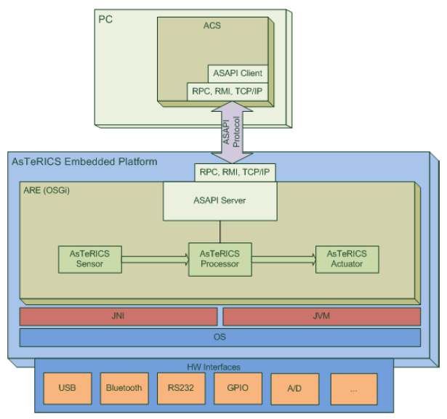

Figure 1: The original AsTeRICS architecture

As mentioned above, the ARE component is based on OSGi. This gives us the advantage of parallel execution of the internal ARE components and the ability of importing possible code extensions with ease. Everything is implemented as an OSGi bundle and the bundles are communicating together with virtual ports and channels (also OSGi bundles). From an OSGi perspective, we can categorize the bundles to:

1. *AsTeRICS Model specific bundles*

These are the model components used to implement the model’s sensors, actuators and processors. Every component defines additional information about its nature in an XML file called bundle descriptor.

1. *Ordinary OSGi bundles*

In this category there exist OSGi bundles that either manage the AsTeRICS Model specific bundles such as the core functionality of the ARE middleware, or are responsible for the communication either between the AsTeRICS Model specific bundles (virtual ports), or the communication of the ARE with the outside world.

Figure 2 shows an OSGi-oriented overview of the ARE architecture.

**ASAPI Protocol**

**ACS**

**ARE**

**OSGI**

**Container**

**OSGI Components**

**Middleware**

**AsTeRICS**

**Specific Bundles**

**ASAPI**

**Server**

Figure 2: An OSGi-oriented overview of the ARE architecture

## Architectural Updates and Developments to the AsTeRICS Architecture: Rest Services

In the context of the Prosperity4All project, the communication medium between the ARE and the ACS will be refined. The aim is to eliminate any communication limitations of the ASAPI protocol and allow a pure network based communication facilitating the “accessibility for all” concept of the Prosperity4All project. The aim is to implement a REST enabled ARE that will be easily accessible and manageable via the “open” network (see Figure 3), not only by the ACS, but by any other program as well that needs to communicate with it, e.g., the URC and MyUI. The communication with the ARE will be thus exclusively over “open” network through the help of the HTTP protocol.

One of the main requirements for refining the communication medium between the ARE and the outside world was to provide the capability to integrate the very large set of assistive functionalities offered by the implemented AsTeRICS model components into existing applications. The target was to still facilitate the design and development of assistive applications through the use of the ACS, but at the same time enable integration of assistive functionalities into existing software applications implemented in different technologies. In specific, the ASAPI substitution offers platform and language independence. This means that a developer is able to reuse and integrate assistive functions into existing software applications, without any concerns about the language and/or the platform used to implement and deploy the applications. Finally, the development effort is reduced and the development process is simplified since these assistive functionalities have already been implemented in their majority, reducing also the costs of integration.

The HTTP communication protocol offered via the REST architecture style will be exploited, but it needs to be taken into consideration that this needs to be done within an OSGi container. To “talk” HTTP we have used an HTTP server (Grizzly server) implemented within an OSGi bundle [6]. This bundle uses an embedded OSGi service, called HTTP Service. In this implementation the server is used as an internal component that is able to interact with any other component in the ARE, while at the same time communicate over the network.

Regarding the ACS, in order to be able to communicate with the REST enabled ARE, it must be updated to include the corresponding functionality. In fact, the newly implemented Web-ACS must define a REST Client that issues specific requests to the ARE’s REST server using the newly developed REST API.

**WEB ACS**

**ARE**

**OSGI**

**Container**

**HTTP Server**

**OSGI Components**

**Middleware**

**REST Server**

**AsTeRICS**

**Specific Bundles**



**Network**

Figure 3: The REST enabled ARE architecture

**ARE Status Service**

Apart from the Restful communication, the new ARE will provide an additional service called “ARE Status Service” by which any interested platform/system/program will be able to automatically be informed about the current situation and status of the ARE. More particularly, Server-Sent Events (SSE) Support [7] that adheres to the HTTP protocol will be used, in order to allow communication only via a single protocol and enable the ARE to asynchronously push “State” related information to any client registered to a specific service. This follows a publish-subscribe mechanism that any client software can exploit in order to subscribe and receive notifications for ARE events that are of interest (e.g. a different model has been deployed directly using the ARE). Once the connection to the ARE will be established by the client, the ARE (playing the role of the server) will push the required information at the appropriate time. This service aims to provide a way for other programs such as the Web ACS, URC and MyUI to be informed and updated about the ARE status by registering to it as clients. Figure 4 presents the refined architecture of the ARE and in specific provides details on the new REST architecture style and the HTTP communication model of the ARE. Note that the client(s) needs to subscribe using the SSE mechanism, so as to enable the server to keep a connection alive and push messages on the required events.

**ARE Status Service Registered Clients**

**WebACS**

**ARE**

**ARE Status Service**

**Client**

**Client**

…

Push State messages

**ARE REST Services**

**Client**

**Client**

…

REST request-response

REST request-response

REST request-response

REST request-response

REST request-response

Figure 4: “ARE Status Service” and REST Services Architecture

The ARE REST API was developed by UCY under T203.3 (D203.1) and can be found in ANNEX I of this document which can serve as a developers manual.

# Universal Remote Console (URC)

## Aim

This section describes the architectural updates and developments to the Universal Remote Console [8] in the context of the Prosperity4All project. Due to the close relationship between the URC-Standard and the Universal Control Hub (UCH) [9] as its implementation they are both considered in this section. The described modifications relate to an appropriate integration of AsTeRICS, MyUI and URC. Thereby, one major task was to implement a Java based, client side library of the URC-http protocol [10, 11] in order to enable communication between ARE and UCH.

Furthermore, a new, standalone version of the UCH was developed. This simplifies the deployment of the UCH noticeable. This is due to the fact that no additional installation and configuration of a Tomcat server is needed anymore.

Finally, in order to support the use cases described in section 6, a number of UCH modules were developed to connect to the Philips Hue, the electricity outlet Wöhlke Websteckdose and the VLC player.

## Background

The overall purpose of the URC framework (standardized in ISO/IEC 24752) [12] is to provide a mechanism, enabling users to control any target with any controller devices fitting best the user’s needs. Targets can be devices or services, usually such that can be found in the Smart Home or Ambient Assisted Living domain. Controllers can range from User interfaces running on PCs, Smart Phones over traditional Remote Controls to regular or specialized hardware.

In order to realize such a system every target provides an abstract description of its operating interface. In URC terms this is called a User Interface Socket Description - or just Socket Description. Socket Descriptions contain all information about a devices properties that can be accessed by a user. Basically, this are variables that can be controlled by the user, commands that can be send to the target, and finally notifications that the device can send to a user interface.

Based on the concept of Socket Descriptions, third party user interface developers can create personalized user interfaces, and publish them via a dedicated Resource Server. At runtime, users can select a user interface fitting best their needs, download it from the Resource Server and virtually plug it into a target. This is why they are referred as pluggable User Interfaces

As a solution for applying the concept of Sockets to not URC compliant targets the Universal Control Hub was developed. In the backend it has mechanisms to discover different targets from different technologies. As soon as a target is discovered its Socket Description is downloaded from the dedicated Resource Server and exposed to the user. Consequently, the principle of pluggable User Interfaces is again applicable.

To enable the communication between any user interface and the UCH, the URC-HTTP protocol was developed. The UCH reference implementation ships with a Component implementing the server side of the URC-HTTP protocol. All received messages are transformed by the UCH in target specific ones and forwarded to the appropriate target.

## Original architecture

When considering the URC architecture two main cases must be distinguished. The first one is when targets and Controllers are totally compliant to ISO/IEC 24752. Most important is here, that targets expose their Socket Descriptions on their own. If communication between a not standard compliant controller and/or target shall take place case 2) the Universal Control Hub provides a middleware solution to integrate the different communication partners. In this case the UCH is responsible for exposing the targets’ Socket Descriptions.

### ISO/IEC 24752 compliant communication

The international standard ISO/IEC 24752 specifies communications between a target that a user wishes to access and operate, and a universal remote console (URC) that presents the user with a remote user interface through which they can discover, select, access and operate the target. The URC is a device or software through which the user accesses the target. If the URC is software, it is typically hosted on the user's physical device, but a distributed approach is also possible.

Communications between the target and URC take place over a network, the target-URC network. Iso/IEC 24752 does not specify the network protocol to be used, and a target or URC may support any number of appropriate connection protocols. These protocols are used to provide discovery of targets, and to establish and maintain control sessions between URCs and targets. Targets and URCs access the target-URC network through target-URC network links. Targets support discovery by providing essential information in a target description. Among these information is the link to the target’s abstract description of it’s operating interface – the User Interface Socket Description (see below).

Each target provides a User Interface Socket (or short Socket), or set of Sockets, through which a URC can access part or all of the target's internal states and provide control inputs to the target. For each Socket, a target provides a dedicated User Interface Socket Description (or short Socket Description) in a XML-file which describes the Socket in a machine interpretable manner.

All in all there are three types of socket elements whose state is synchronized between a target and a connected URC and that must be described in a dedicated Socket Description.

* Variables are state variables of the target and can typically be changed by the URC,
* Commands represent function calls on the target that can be invoked by the URC,
* Notifications propagate special target states in which normal operation is suspended on the target and requires a notification or action of the user.

Additionally the target provides resources that pertain to the user interface of the target, as viewed through that Socket. The Socket Description and resources are used by the URC to find or generate an appropriate user interface, given the functionality of the target, the nature of the URC device, and the user's interaction preferences.

Resources can either be provided by a target itself, by the URC or by a dedicated resource server. Resources can range from different user interfaces to exchangeable parts of an User Interface. Latter could be labels in different languages, as well as additional help items (e.g., in text format or as sign language videos.

Dependent on the implementation of the URC users can either choose their preferred User interface on their own or it is automatically selected by the URC according to some context or personal information. If it is not available on the URC or on the target it is downloaded from the Resource Server. After the selection of a user interface it is virtually plugged into a targets Socket.

Interaction between a target and a URC consists of a discovery phase and an optional control phase. The discovery phase initializes the URC to locate and identify all available targets and their sockets. The control phase is the time period during which a target and a URC initiate, maintain and terminate a control session. A control session is a connection between the URC and a target's socket for the purpose of the URC controlling a functional unit of the target via the socket. When multiple URCs are connected to the same Socket, each has an independent control session, although target state values may be shared [8].

### Enabling none-standard compliant communication via the Universal Control Hub

Today, we are encountering a growing number of networked devices and services at private and public places. However, these devices and services are using different networking platforms and technologies. Some of them are already standardized but there are also many proprietary technologies available. There seems to be no chance to get all manufacturers of these devices and services together to agree first to adopt the URC standards, and second to use a specific Target-URC Networking protocol for communication between URCs and targets. Instead, a different solution must be sought that can harvest the benefits of the URC standards, and works with existing devices and services available on the market.

This is where the Universal Control Hub (UCH) comes in. It is a profiling of the URC standards that implements standard-conforming targets and URCs "in a box", providing connection points to existing targets and controllers that are not URC-compatible. The UCH is a middleware that establishes a control connection between non-compliant controller and non-compliant target devices/services that would otherwise not understand each other. The UCH is designed to be extremely extensible and scalable with regard to diverse targets and controllers. By using the mechanisms as defined in ISO/IEC 24752, it provides an open platform for pluggable user interfaces that are based upon User Interface Sockets.

In the UCH architecture (see Figure 5), any network-enabled device/software can be used as "controller". Also, the "target" is a network-enabled device or service that can be remotely controlled via any networking platform. Note that this is different from a "conforming target", as defined by ISO/IEC 24752-1:2008. The "conforming URC" and "conforming" targets are virtually folded into the UCH and its components.

The UCH discovers a target through a Target Discovery Manager (TDM), and controls it and receives events from it through a Target Adapter (TA). To a controller, the UCH makes itself discoverable through the UIList, an extended UPnP RemoteUI mechanism, as defined in [CEA-2014-A].

The UCH communicates with a controller for the purpose of target control through a User Interface Protocol Module (UIPM). By connecting to controllers and targets through these device and network-specific adapters, the UCH talks to them in their native language. Acting as a middleware, the UCH then translates the communication with targets and controllers into the "URC language", exposing the targets and their functions as sockets that the controllers can access. Thus the UCH bridges between non-conforming controllers and non-conforming targets, fulfilling the URC requirements on behalf of them.

There are many middleware products existing that bridge between controllers and targets in a similar way. What is unique for the UCH is that it uses a standard approach for the translation between targets and controllers, thus opening a way for third parties to make their pluggable user interfaces and accompanying resources available to the UCH after installation. The UCH constitutes an open platform for control interfaces that uses the mechanisms defined in the URC framework to allow for pluggable user interfaces and supplemental resources dynamically at runtime.

Moreover, the UCH architecture is designed to be extensible for new targets and controllers.

The figure shows the interaction between a controller, a UCH and a target. 

The UCH is further composed into the following parts: UIList, UIPM, UCH (Socket Layer), TDM and TA. 

The following interactions take place, indicated by arrows in the figure. For some interactions, proprietary or standardized interfaces are used on either
end. Order follows approximate chronogical order in a running system.


• 2-way interaction between UCH (Socket Layer) (TDMListener interface)     and TDM (ITDM interface)
• 2-way interaction "Discovery" between TDM (proprietary interface) and     Target.
• 2-way interaction between UCH (Socket Layer) (ITAListener interface)     and TA (ITA interface)
• 2-way interaction "Control" between TA (proprietary interface) and     Target
• 1-way interaction between UCH (Socket Layer) and UIList.
• 1-way interaction "Discovery" between UIList and Controller.
• 2-way interaction between UIPM (IUIPM interface) and UCH (Socket Layer)     (IUIPMListener interface)
• 2-way interaction "Control" between UIPM (proprietary interface) and     Controller.


Figure 5: The Universal Control Hub (UCH) Architecture

Except for the core UCH (socket layer), its components (blue boxes: UIPMs, TDMs and TAs) are embedded into the UCH through well-defined APIs (red vertical boxes attached to the components). Any party can develop such components, and a UCH can load them at runtime. This mechanism is extremely powerful in conjunction with a resource server (see below). Then new targets and new controllers can be integrated into a local UCH system on the fly, by downloading the appropriate components from the resource server [13].

### URC-HTTP Protocol

In the UCH architecture, a UIPM is responsible for presenting one or multiple sockets to the user through a user interface that is rendered on a controller. In some cases, controllers and their software themselves might have knowledge about the URC technology, in particular about sockets and their resources (These controllers are "conformant URCs", as defined by ISO/IEC 24752-1:2008.) They might want to get direct access to a target's Socket and pertaining atomic resources, in order to build a suitable user interface based on the Socket elements and their values.

However, in most cases either the Controller or the target is not complaint to ISO/IEC 24742. Therefore, the URC-HTTP protocol, as defined by [10], facilitates direct access for a controller to the sockets running in a UCH. This protocol defines HTTP-based messaging for a controller accessing the sockets on a UCH and its functions. An optional TCP/IP-based update channel is also defined to inform controllers about status updates of connected targets.

The UCH open-source reference implementation by the Trace Center includes a UIPM for the URC-HTTP Protocol.

The URC-HTTP protocol is designed to be usable by clients running in Web browsers, such as scripts and plugins. For example, with the Webclient JavaScript Library [14] that is available via the openurc.org website.

## Updates of the URC Architecture

In order to integrate the UCH with the AsTeRICS runtime (ARE) and the MyUI framework, several updates are mandatory.

In order to enable a direct communication between the AsTeRICS runtime, which is OSGi-based, and the Universal Control Hub it was necessary to transform the Java Script based Webclient library [14] to a Java implementation. This work was done by UCY in cooperation with HDM.

Furthermore, a new, standalone version of the UCH was developed – the UCH 4.0 – by HDM. The new version ships with its own embedded tomcat server and does no more rely on a separately installed servlet container. This simplifies the deployment of the UCH noticeable. This is due to the fact that all required configuration is already set in the UCH package itself and the installation and configuration of the separate servlet container has become obsolete.

The development of the new UCH version was necessary to enable a future integration with the GPII infrastructure and also the MYUI and ARE (AsTeRICS framework). When logging in to a system with a GPII installation not all GPII supported components are available. Hence it must be possible to easily deploy further components at runtime. The new UCH version 4.0 meets this requirement. It can be downloaded at runtime by any third party and the executable jar file can be started without any further installation or configuration (for installation instructions please refer to ANNEX III of this document). Finally, in order to realize some illustrative use cases, the following target discovery modules and target adapters were developed and/or updated by HDM:

* Wöhlke Websteckdose: The Wöhlke Websteckdose is a multi-electricity outlet that can be located in the network. It is very generic in the sense that it can be used to remotely switch on or of any electric device (e.g. fan heater). Modules to discover, configure and control a Wöhlke Websteckdose via the UCH were already available, however, some minor bug fixes were required.
* Philips Hue: The Philips Hue is an illumination system that can be used to create spatial ambiances. During the project, a new target discovery module, a new configuration manager and a new target adapter were developed.
* VLC Player: The VLC Media Player is a well-known Media system. During the project, a new target discovery module, configuration manager and target adapter were developed in order to control a VLC media centre that is located in the network.

All UCH components that were developed/updated are based on the target adapter framework developed in task 202.4.

# MyUI

## Aim

This section describes the architectural updates and developments to MyUI [15] in the context of the Prosperity4All project.

## Background

MyUI provides an environment to render and adapt a user interface to the user context during runtime. All knowledge on various user interface design solutions and adaptations is contained in design patterns. MyUI provides also an abstract format to define the interaction possibilities of a user with the application called AAIM (Abstract Application Interaction Model) which is based on UML2 State Machine Diagrams. Instead of developing many variants of the user interface in order to meet the individual needs of the diverse end users, the application developers can focus on implementing the application logic. The knowledge about the user interface adaption lies in the pattern repository.

### Adaption mechanism

User interface adaptations in MyUI follow a three-stage process (see Figure 6) including the User Interface Parameterization, the User Interface Preparation as well as the User Interface Generation and Adaptation. A summary of each stage is described in the following sections, for the full description please refer to the MyUI Developer Documentation [16]. After significant user profile updates the process of user interface adaptation starts again.

There are three main steps in the adaption process of MyUI: the UI Parameterization, the UI Preperation and the UI Generation & Adaption.
The UI Parameterization step includes following pattern types transform data into the User Interface Profile:
-Device-specific patterns. input: available knowledge about the current input and output devices, output: device profile
-Individualization patterns. input: device profile and user profile, output: user interface profile, except for the customization-related variables which goes directly the User Interface Profile.
The User Interface Profile is the base for the UI Preperation step. This Profile and additionally the Abstract Application Interaction Model (AAIM) and the User Interface Elements are inputs for the Interaction Patterns in order to select the most suitable user interface components and elements for the current situation.
The UI Generation & Adaption step includes the Selected Components, the output of the user interface preparation process. The Selected Components flow into User interface. Additionally Adaption Patterns are used to determine how to move from one instance of a user interface to another.

Figure 6: Overview on MyUI approach to adaptive User Interfaces

**User Interface Parameterization**

In a first step, general user interface characteristics are set in order to adapt the overall user interface appearance and interaction mechanisms to a specific user, specific I/O devices and a desired corporate or product identity. These general user interface settings are done via global variables and stored in the MyUI User Interface Profile. A MyUI User Interface Profile is initiated at the beginning of a new interaction session with a MyUI application. A repeated User Interface Parameterization cycle (i.e. user interface profile update) is triggered when newly available information about the user and his/her context leads to a significant change in the user profile.

**User Interface Preparation**

On the basis of the current interaction situation and relevant variables of the user interface profile the most suitable display and control elements are selected from a repository of user interface components and elements. This second step makes sure that the selected user interface building blocks correspond to individual user needs and device-related requirements. It is triggered whenever a new state of the application is entered (i.e. a new interaction situation is active) and after each user interface profile update. The new selection of display and control elements is compared with the currently displayed selection. If a difference between the current and the new components is identified, adaptation patterns to switch from the current to the new user interface are selected in the next step.

**User Interface Generation and Adaptation**

The selected display and control elements are composed and rendered to an individualized user interface. This rendering process takes place at the beginning of a new interaction session with a MyUI application in order to generate the interface. The same process is also triggered when in the user interface preparation process (step 2) a new set of display and control elements is selected. In this case, also the selected adaptation patterns are executed to switch from the current to the new user interface.

### MyUI components

In this figure there are on the one side the user groups Developer and End User and on the other sides the main components of the MyUI infrastructrue.
Developers are using the component Development Toolkit including the Abstract Application Interaction Model. The Development Toolkit has a connection to the Adaption Engine, which is in the middle of the figure. Additionally the Adaption Engine has a connection to the Design Patterns as well as the Adaptive User Interface and the User Profile.
End Users are using the Adaptive User interface and influence the User Profile so there is an circle between the Adaption Engine, the Adaptive User Interface, the End User and the User Profile.

Figure 7: Schematic diagram of the main components of the MyUI infrastructure

**MyUI Runtime**

The MyUI Adaptation Engine generates and adapts the user interface for a specific end user in a specific context. The Adaptation Engine composes individualized user interfaces from reusable software components during runtime. Even if the current focus is accessibility the MyUI Runtime can be used for all kinds of adaptions so all users can profit from a tailored user interface. The implementation is based on CakePHP, MySQL (Server, other DBs possible) and jQuery (Client) and runs on every PHP-enabled webserver. It does not have an interface on its own but generates all of the applications adaptive interfaces.

**MyUI Context Manager**

The MyUI User and Context Management Infrastructure detects and interprets relevant characteristics of the end user and her/his environment which bring about special accessibility requirements. This information is stored and updated in a user profile which serves as basis for generating an individualized user interface. If context conditions change, the MyUI user interface is adapted immediately e.g. because the attention threshold is lower in crowded places the system will show less elements per screen. It is implemented using C# and SQLite and should run on every platform with a .NET runtime environment available. Besides the console-based server there is a client application with a graphical user interface for management of the context manager server.

**MyUI Development Toolkit**

The MyUI Development Toolkit provides intuitive and efficient tools and mechanisms to user interface developers and designers for the creation of MyUI applications with the MyUI adaptive user interfaces infrastructure. By the use of an additional abstraction layer (an abstract model of the UI) developers do not need to implement concrete/final user interface solutions, rather they define and model the interaction possibilities the users have when using the system. The tool is implemented as a plugin for the Eclipse IDE in Java. It depends on the Eclipse PDT (PHP Development Tools). For the preview feature the development toolkit requires a local installation of both the MyUI Runtime and Context Manager.

## Original architecture

The implementation of the MyUI Runtime Environment is built up as a CakePHP plugin. The CakePHP plugin approach helps developers to easily extend their applications with reusable software components (plugins). A CakePHP plugin contains its own models, views and controllers as well as its own webroot folder where images, css files, javascript libraries etc. are located. Each CakePHP plugin is saved in the plugins folder of the main CakePHP application. The general folder structure of a CakePHP plugin looks like follows:

plugin\_name/

controllers/

components/

models/

views/

elements/

helpers/

webroot/

MyUI is also following this plugin structure. The controller package contains the controller classes such as the profiles\_controller and applications\_controller together with the individualization\_patterns component. Classes representing real objects are stored in the models folder. Unlike normal CakePHP plugins the MyUI Core plugin does not contain fully implemented views in its views directory. Instead it makes heavy use of the CakePHP elements mechanism to generate the user interface structures out of interaction patterns and user interface elements at runtime. Besides that, plugins can integrate own external content or libraries such as images, javascript files, css files etc in the webroot folder. The MyUI Core plugin, the adaptation engine itself and the adaptation handlers are located here. The complete structure of the plugin is shown in Figure 8.

There are 4 main packages in the MyUI core plugin: controllers, models, views and webroot.
The package controllers consists of components Applications Controller and Profiles Controller. Additionally there is a sub-package called components including the Individualization Patterns.
The package models consists of the components Application Model and Deviceprofile Models.
The package views consists of the sub-packages elements and helpers. Elements includes two other packages interaction_patterns and ui_elements. interaction_patters includes MainMenu, ListWithAttributes etc. the package ui_elements includes Buttons, Preview, TextField etc.Inside the helpers package is the MyUI Helper component.
The webroot package consists of three sub-packages js, css, and images. Js includes the AdaptionEngine and inside the package handlers the Adaption Handlers. Css has the MyUI Base Stylesheet and the images package includes Images.


Figure 8: Package diagram of the MyUI cakePHP solution

## Updates to the MyUI Architecture

Rather than changing or adding parts of the existing implementation, the MyUI runtime environment has been entirely reimplemented in Prosperity4All. Due to the purely browser-based implementation using JavaScript and HTML5 it does not depend on any server-side technology. Along with that the runtime implementation has been structured to allow for modular extensions: Different user interface solutions can be represented by different situation factories, additional data sources and functionality can be integrated using additional services. From an implementers view, the AAIM that is represented by a JSON data structure has been upgraded to be the central point of configuration for a MyUI-based application using existing sets of user interface components and backend services.

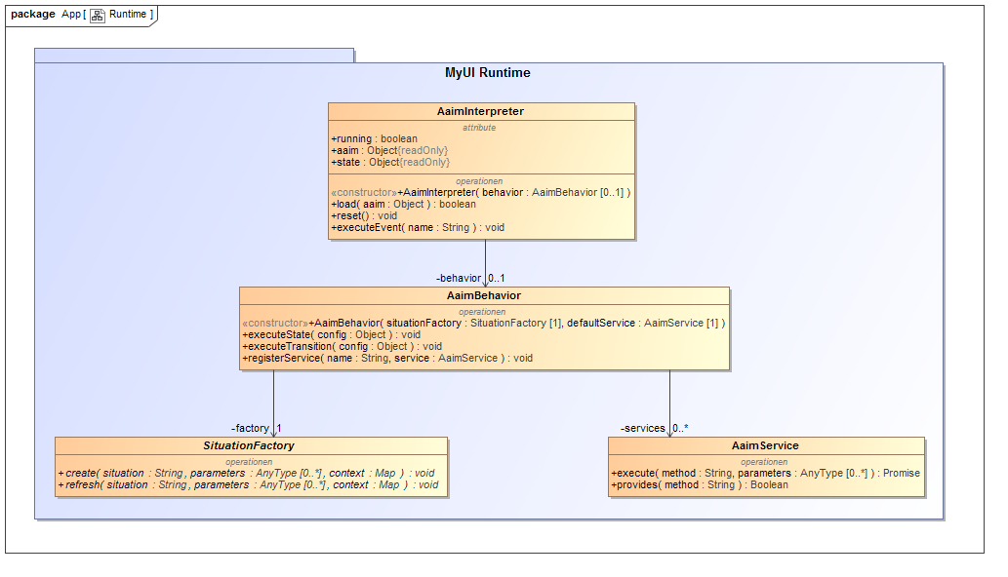

Figure 9: Implementation structure of the MyUI Runtime

The capabilities of adaptive user interface components will be built upon the self-adaptive UI modules currently being created in T202.6 and are therefore not yet covered by the MyUI runtime implementation described here. Due to its modular structure till the integration of these, other web frameworks may be used for the implementation of user interface components. For example, the current demonstrator is implemented using the Polymer Framework[[1]](#footnote-2).

# Integration of AsTeRICS, URC and MyUI platforms

Through the integrated runtime environment this work also attempts to address two scientific challenges: firstly, how to offer appropriate interactions to heterogeneous groups of users, and secondly, how to overcome interoperability problems of heterogeneous devices and services. We address the above mentioned challenges by enabling the integration of Adaptive User Interfaces and Middlewares, aiming to support real life Assistive Technologies and Internet of Things scenarios. When developing this prototype, a key requirement was to address adaptivity, not only at the graphical level, but also to support people with special motoric needs in Assistive Technologies scenarios. For more information on the above scientific contributions the reader is referred to the following scientific paper published based on this work [17].

The integration of the 3 main platforms, AsTeRICS, URC and MyUI rely on a RESTful based communication. The aim is to accomplish an efficient, effective and straightforward way of communication and exchange of data, information and resources between these components, while at the same time maintaining the ability for other programs to be able to potentially communicate with the new system of platforms. Figure 10 depicts the 3 main platforms under the GPII. GPII (C4All Matchmaker) initiates the AsTeRICS runtime (ARE) in order to execute/manage a model. The GPII is able to identify the user via NFC communication and based on the needed solution that best accommodates the needs of the user, starts the appropriate AsTeRICS model. Currently the model is started by initiating a local command from the GPII to the ARE, since both software platforms are running on the same machine. Our aim is to achieve a RESTful based communication between the GPII and the ARE so that ARE management can be done remotely by the GPII. To achieve this, a RESTful client implementation on the GPII is needed, which is left for future work. MyUI also communicates with GPII to load the preferences from the GPII preference store. Additionally, AsTeRICS communicates with URC by including the URC Remote Component as an AsTeRICS model component within the ARE.

**AsTeRICS**

**URC**

**MyUI**

**GPII**

URC Remote Component

Figure 10: The 3 main platforms under the GPII

## Integration Schema

After examining a number of integration possibilities between the 3 platforms [18], we have resulted to the schema mentioned below as the most appropriate one that is able to offer good communication between the platforms, remote platform management and dynamic exchange of information. Figure 11 shows the final integration schema.

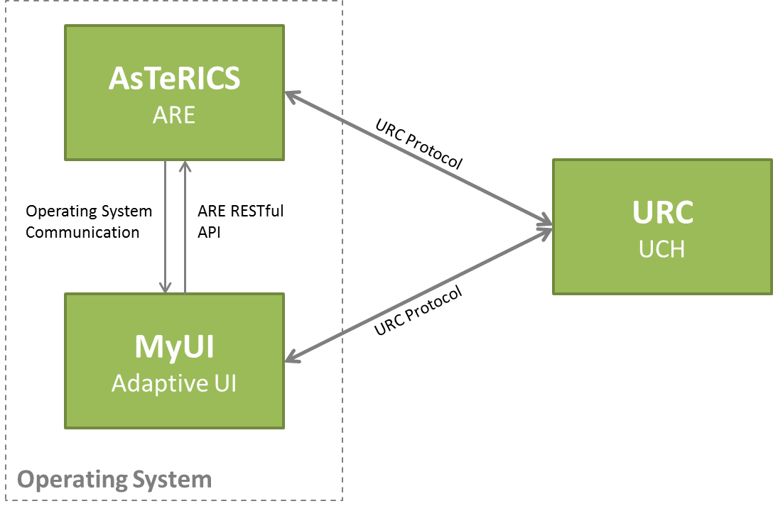

Figure 11: Final integration Schema

In this integration schema, ARE and MyUI communicate with the URC using the URC-HTTP protocol. This protocol is offered in JavaScript. UCY implemented the URC-HTTP protocol in Java for the needs of the ARE-URC communication. To achieve URC remote sensor/actuator management/communication from within the ARE, a URC remote controller was developed as an AsTeRICS model component that runs within the AsTeRICS model and which contains a *URC actor component* that is able to communicate directly with the URC remote sensor/actuator via the URC-HTTP protocol (see Figure 12). The result is enabling access to remote URC sensors/actuators and other H/W from within an AsTeRICS model, meaning that remote URC sensor information (e.g. the temperature of a remote thermostat) or actuator process (e.g. switch on a heater) can be initiated from AsTeRICS model components and reused throughout a number of AsTeRICS models.

MyUI Adaptive User Interface also communicates with the URC via the URC-HTTP protocol.

The communication between ARE and MyUI is bi-directional and is conducted in a different manner for each direction. The ARE → MyUI communication is loose and stretches over the operating system. The AsTeRICS model running in the ARE is emulating default operating system events like mouse or keyboard interaction to control the MyUI Adaptive User Interface running on the same machine. What is achieved is to enable the usage of MyUI Adaptive User Interface to accommodate the preferences of a user in terms of the user interface (e.g. large fonts and medium images), while at the same time enabling AsTeRICS smart accessibility and AT functionality (e.g. handling the computer mouse via head movement through a camera).

MyUI → ARE communication is conducted via an appropriate MyUI Adaptive User Interface that is able to manage the AsTeRICS ARE through a RESTful communication. Via this interface, MyUI Adaptive User Interface is able to receive relevant updates of the ARE’s application state and runtime information.

## RESTful based communication between the AsTeRICS ARE and the other platforms

Figure 12 shows the RESTful based communication between the AsTeRICS runtime and the two other platforms, mainly URC and MyUI. Any program will be able to use the REST interface to communicate with the ARE. In the same figure the Server-Sent Events (SSE) Support can also be depicted as the “Push state Messages”.

Currently, the communication means from the AsTeRICS ACS to the AsTeRICS ARE is conducted via the ASAPI protocol, which is to be replaced by a more easy to implement and adopt, as well as more flexible RESTful interface. This RESTful implementation is currently developed on the server side (ARE). The REST functionality allows communication of the outside world with the ARE, providing thus the ability to manage the runtime environment by specifying a group of actions that ARE can perform during runtime, such as to start a model, to stop a model, etc.

However, the actual model that is being run cannot be adapted during execution. The model and all its components (sensors, processors, actuators, ports, etc.) have to be predefined at development/design time. This adds complexity when one (or more) of the components of the model being run in the ARE runtime needs to be an outside component, i.e. a component of another platform. An example is depicted in Figures 10 and 12, where the thermostat component handled by the URC platform needs to be included within an AsTeRICS model that is running on the ARE. This can be accomplished only by predefining at development and design time the thermostat component and its connections to other components in the AsTeRICS model. Let us name this **A**sTeRICS **ther**mostat component as “Ather” component. This component, while running on the ARE, must be able to communicate with the UCH platform in order to manage the actual thermostat sensor. In Figure 12 this communication is shown as *“Cross Component Communication”*, since the Ather component while being an AsTeRICS model component, must communicate with the actual thermostat sensor (URC component).

**GPII**

**(Preference Store)**

Initiate appropriate Model execution

**URC**

**(Socket Builder)**

**MyUI**

**(Interaction Modeller)**

**ACS**

**(Model and Mapping)**

REST request-response

Deployment of Socket Description

Deployment of WebApp

Runtime

REST request-response

**ARE**

**MyUI**

**(HTML GUI)**

**UCH**

**socket**

Push State messages

**Model Running**

Ather component

Cross Component Communication

**thermostat**

Figure 12: Integration of the 3 platforms: AsTeRICS, URC and MyUI

To achieve cross component communication, an AsTeRICS Ather component was developed that is able to communicate via REST through the UCY developed Java based URC-HTTP protocol with URC. This component is able to be used within any AsTeRICS model and can connect to other AsTeRICS model components for inner model communication, while at the same time it includes the appropriate REST functionality to communicate with URC. UCY will specify generic guidelines as to how a developer can design and implement her own, but the development will be left upon the developer.

## Integration of ARE and UCH (Cross Component Communication)

The ARE-URC integration takes part on component level, meaning that when a scenario defines a URC sensor to be managed, a corresponding component should exist in the ARE. This ARE component will be capable to monitor/manage/coordinate the URC remote sensor over the network.

To communicate with the URC server and components, a java library that implements the URC-HTTP protocol was a necessity. Due to the fact that such a library did not exist, UCY took over the responsibility to create one that provides a complete set of functions which will cover all possible scenarios demanding ARE-UCH integration.

Among other capabilities, the UCH-communication java library (UCH jClient) allows ARE components to:

1. Discover URC server’s location in the local network with a zero-configuration networking (zeroconf) implementation (see Figure 13). With JmDNS [19], the UCH jClient is searching in the local network for the UCH zeroconf service. If found, the UCH jClient is able to retrieve the IP address of the machine that hosts the server and proceed with the communication procedure.

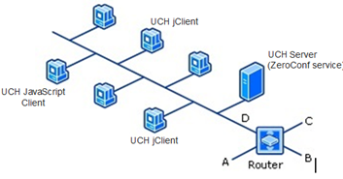

Figure 13: Local network example

1. Make out-of-session URC-HTTP requests to discover which URC components are running on the UCH server and retrieve all the available information for each one of them (static information). Using the **UCH-communicator object**, any java client can query the UCH server repository and obtain the UIlist, an xml formatted list with the running URC components descriptions. Every element of this list, contains information needed for the communication, such as the component id and its Socket Description. Below it is depicted a snippet of code capable of doing this

Functions in the snippet:

- uchCommunicator.getAllUiIds()
- uchCommunicator.getUiName(uiId)
- uchCommunicator.getSocketDescriptionURI(uiId)




1. When needed, the UCH-communicator object can create **session objects** which are following the URC-HTTP protocol as described in the URC documentation [10]. Every session object can send in-session requests to monitor/change the state of the URC components using a unique session id. The following is an example of how to create a session object:

Functions in the snippet:

- String sessionId = uchCommunicator.createSession_getRequest(httpUrcURI);

- UchSession session = uchCommunicator.getSession(sessionId); 

More information on the UCH java library with the complete set of functions for ARE-UCH integration can be found in ANNEX II of this document.

## Integration of MyUI and UCH

The MyUI runtime contains two concepts for binding user interfaces to application data and functionality. *Data Acquisition Functions* are used as data sources for information to be presented by the generated user interface. Accordingly, *Application Functions* represent application specific actions to be triggered by the user interface. In the implementation of the MyUI runtime both types of functions are provided via implementations of the base class AaimService. Therefore, this base class serves as the appropriate integration point for the communication with the UCH.

The services are themselves implemented in JavaScript and executed in the web browser. Hence, the existing URC Webclient JavaScript Library [14] builds the foundation for the implementation of a generic UchService as shown by the class diagram in Figure 14.

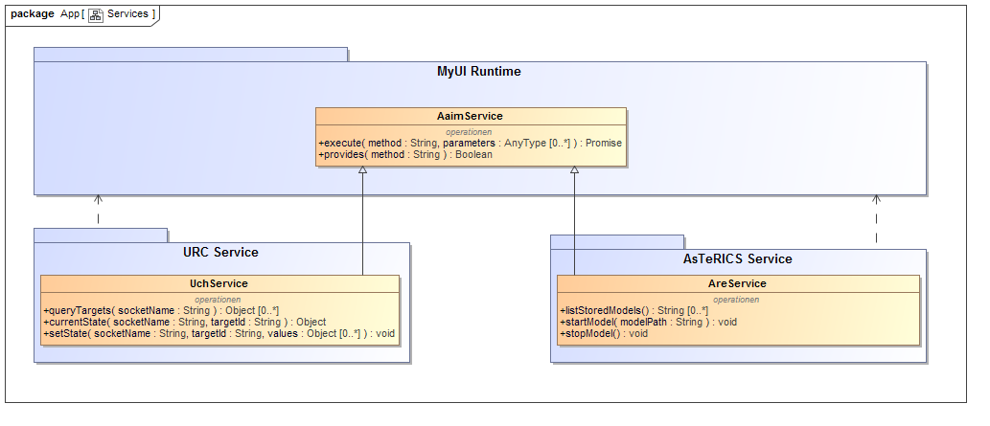

Figure 14: Services for the integration of MyUI with URC and AsTeRICS

An example of a service function that may be used as a *Data Acquisition Function* is presented in Listing 1. The queryTargets method uses the function getAvailableSockets provided by the URC Webclient library to return a list of all targets provided by the UCH instance. The list may be filtered to only contain targets that match a given socket definition. Another method that can serve as data source is currentState which uses the URC getValue function to fetch the current values of the socket variables of a specific target.

queryTargets(socketName) {  
 let allTargets = org\_myurc\_urchttp\_getAvailableSockets();  
 if (socketName) {  
 return allTargets.filter(function(target) {  
 return target.socketName === socketName;  
 });  
 } else {  
 return allTargets;  
 }  
}

Listing 1: Implementation of the queryTargets method in the UchService

*Application Functions* on the other hand typically perform actions or change data. An example for this type of service methods in the UchService is setState (see Listing 2). It is implemented using a call to the setValues function of the URC Webclient.

setState(socketName, targetId, values) {  
 org\_myurc\_webclient\_init([socketName], 0);  
 let elements = [];  
 for (let val in values) {  
 elements.push({  
 elementPath: "/" + val,  
 operation: "S",  
 value: values[val]  
 });  
 }  
 org\_myurc\_webclient\_setValues(socketName, elements, targetId);  
}

Listing 2: Implementation of the setState method in the UchService

## Integration of MyUI and ARE

To allow asynchronous services, the AaimService implementation in the MyUI runtime is based on the concept of promises [20]. Return values of service methods are wrapped into promises while promises returned by service methods are forwarded unchanged. This enables the AreService implementation to use the asynchronous ARE REST API (see section 2.4) to provide *Data Acquisition Functions* (see listStoredModels in Listing 3 as an example) as well as *Application Functions* like starting and stopping models.

listStoredModels() {  
 return new Promise(function(resolve, reject) {  
 listStoredModels(function(data, httpStatus) {  
 resolve(data);  
 }, function(httpStatus, message) {  
 reject(new Error(message));  
 });  
 });  
}

Listing 3: Implementation of the listStoredModels method in the AreService

The capability of the MyUI runtime to load AsTeRICS models into the ARE and start their execution via the ARE REST API leads to the possibility of automatically provide AT interaction mechanisms realised as AsTeRICS models and web-based user interface patterns aligned to each other. Designers may define both parts in conjunction and treat them as one interaction solution. Figure 15 sketches the general communication sequence between the AsTeRICS Runtime Environment (ARE), MyUI and the GPII Preferences Store as a source of user preferences.

UML Sequence Diagram showing the MyUI Runtime that gets the preferences from GPII Preferences Store followed by the detection if an AsTeRICS runtime is available. Based on that information MyUI selects the best fitting pattern. If this pattern contains an AsTeRICS model it is loaded into the AsTeRICS Runtime when the user interface is created.

**Figure 15: General communication flow for MyUI patterns containing AsTeRICS models**

## Communication Routes between AsTeRICS ARE, MyUI and URC

In scenarios where all three frameworks AsTeRICS ARE, MyUI and URC are included, we can identify two communication routes that can be used.

### ARE → MyUI → URC

In this scenario, the communication between the ARE and MyUI is being conducted over the operating system. The AsTeRICS model running in the ARE provides accessibility and AT interfaces to control default operating system events such as mouse or keyboard interaction in order to control the MyUI Adaptive User Interface. The URC-HTTP protocol is being used to communicate between MyUI runtime and URC. The REST calls must be integrated in the Abstract Application Interaction Models as the final application functions being executed. To simplify the communication between the MyUI runtime and the UCH, the JavaScript Library implementing the client side of the URC-HTTP protocol is used. The Abstract Application Interaction Models must be created at development time by a developer or during runtime by parsing the Socket Descriptions being available in the UCH.

### MyUI → ARE → URC

The first scenario requires that an appropriate MyUI Adaptive User Interface exists that manages the AsTeRICS ARE through a RESTful communication. Through this interface, MyUI Adaptive User Interface is able on one hand to initiate REST calls to the ARE to handle models, such as “Start Model”, “Stop Model”, “Pause Model”, “Load Model”, etc., and on the other hand to receive (and display if needed) relevant updates of the ARE’s application state and runtime information.

Following, when an AsTeRICS model has been started and is running, a RESTful communication between the ARE model components and the remote URC sensors/actuators is being established. The AsTeRICS model is then able to retrieve and or push information from/to the remote URC components. This functionality is provided through the URC actor component built within the AsTeRICS model (see Section 5.1). A URC actor component can be designed and built for use with any URC remote sensor/actuator, and can be used by any AsTeRICS model, provided that the corresponding model component interconnections are being properly defined. **This can serve as a good example of Software and Hardware reuse, where a URC actor component (that handles a remote URC sensor) is designed and built once, but reused in many AsTeRICS models of different purposes without further coding needed**. In addition, as the AsTeRICS platform enables a non-expert AT designer to easily model or reuse existing AsTeRICS models to provide the necessary functionality to the user, it can be easily inferred that having URC actor components available to be freely used within AsTeRICS models provides added value to the platform, and the ability to the non-expert AT designer to freely access remote URC sensors/actuators as well.

## Setting up the Integrated Runtime Environment

To setup the Integrated Runtime Environment the reader is referred to ANNEX III of this document “Runtime Environment Setup Manual”. The manual describes thoroughly any prerequisites for installation, as well as the S/W and H/W installation steps needed to successfully install and configure the Integrated Runtime Environment. It also provides a few examples to ensure proper installation.

# Use Case Scenario: Assisted Living

In this section we describe a use case scenario in order to examine how the integration approaches mentioned above can indeed be used effectively in real life situations.

## Personas

We have used the personas described in [21], which were created aiming to reveal the behaviour of various stakeholders in the ecosystem. For the purposes of this deliverable, we have used the following personas:

**Mrs Moroz**

Mrs Moroz has had a stroke a year ago, which paralyzed the right side of her body and took her speech away. Fortunately, she still has good head control which enables her to use a variety of different technologies. For example she is competent in using a head mouse, a mouth stick and a chin control for her electric wheel chair. She spends a lot of her time in an Assisted Living dormitory.

**Nicholas Gallo**

Nicholas Gallo, a 11 year old, was diagnosed with cerebral palsy. He lives in a small town with his parents and younger brother. He moves around in an electric wheelchair, which he controls via a joystick. His hands need to be placed on the joystick by a care-person and then he can use it with very small movements of his fingers. However, using the joystick is exhausting for him. That’s why he prefers to use scanning keyboards whenever possible. Nicholas also spends time in the Assisted Living dormitory.

**Vasili Moroz (Care Giver)**

Vasili Moroz is Mrs Moroz husband, 78 years old and is also the care giver of Mrs Moroz in the dormitory.

**James Olsen (AT Developer)**

James is an independent developer working for the past 15 years in the area of accessibility. He is interested in supporting people regarding accessibility by using open source AT and he is very interested in supplying the Assisted Living dormitory with AT to facilitate the people with moving limitations that spend time there. He is currently working with the DSpace tool and he is excited to discover various solutions, technologies and applications for accessibility within DSpace that he can use as is or extend to meet the needs of the people in the dormitory. He and a small group of passionate AT developers, like experimenting with AT S/W and H/W and find the idea of being AT enablers for the dormitory fascinating. Their future plans include starting a company specializing on providing full AT solutions based on open source platforms, such as the DSpace, therefore the dormitory is an excellent opportunity to start applying AT solutions and test them with real users.

## Environment/Available Technology

Mrs Moroz and Nicholas Gallo spend much of their time in assisted living, a really nice and warm dormitory that provides accessibility. Specifically, Mrs Moroz spends her weekdays there, while Nicholas spends only a few hours on most of the week days. The dormitory has a separate bedroom for every resident and a common room for getting in contact with other people. The common room has two different areas. One is equipped with a TV set and the other one with tables so that people can sit together.

The common room is equipped with Philips HUE lights (a lamp that changes colours remotely controlled by URC – it is a remote URC actuator) so that it can be illuminated to individual colour wishes. Furthermore, there is an electricity outlet (Wöhlke Websteckdose that is remotely controlled by URC – it is a remote URC actuator as well) connected with a fan heater that can be turned on/off from the network. Both Philips HUE lights and the electricity outlet can be controlled from two central devices: i. a touch screen that can adapt to users’ preferences and ii. a TV set that can also be used as a controller device so that users do not have to move when they are watching TV and need to operate the lights or the fan heater. Of course, the TV set also provides an adaptive user interface. Bedrooms are also equipped with Philips HUE lights and fan heating control.

## Personalized Technology Control

The central Philips HUElight and the fan heater can be controlled via the touch screen and the TV set. All three people, Mrs Moroz, Nicholas and Vasili should be able to control them as follows:

**Mrs Moroz:**

* needs to use the headmouse feature
* due to her wheelchair the distance between her and the control panel is about 1.0m to 1.5m

For Mrs Moroz is needed: **headmouse control + increased button size.**

**Nicholas**

* needs to use a scanning keyboard
* due to his wheelchair the distance between him and the control panel is about 1.0m to 1.5m

For Nickolas is needed: **scanning keyboard + increased button size.**

**Vasili Moroz**

* needs to see as many information as possible (e.g., lights + fan heater)
* wants to use a mouse or touchscreen

For Vasili Moroz **no assistive technologies are needed + normal button size.**

**General required adjustments:**

* increased font size/less information for bedridden people due to increased distance between display and user
* different input technologies: head mouse/scanning keyboard/mouth stick

### Room parameter control

Every room has its own control panel which must adjust to each residents’ preferences for that room. The control panel in the room enables controlling the Philips HUE lights and the fan heater in a personalized manner.

E.g. Mrs Moroz does not want to use a headmouse when she is in her private room, while she does want to use it when in the common room. Instead, she would prefer scanning keyboard/eye tracking.

Also, Nicholas wants to use a mouth stick during day time and when he is in his room but wants to use a scanning keyboard when he is in the common room

## Scenario Description

**Scenario Part 1**

Mrs Moroz is sitting in her bedroom where she has set the Philips HUE light and fan heater according to her current needs: “light green” light and fan heater “on”. At some point she uses her electric wheel chair to move to the common room to watch TV. Since nobody has been there for a while, the temperature is lower and the lights are out, so Mrs Moroz needs to switch on the fan heater, as well as control the lights in the common room. She uses the TV set to make the necessary changes so she needs to use increased button size (to be able to read characters from a distance) along with headmouse control. The system makes necessary adjustments to assist Mrs Moroz.

**Scenario Part 2**

After some period of time, Nicholas also enters the common room. He has been out with his parents and brother. He feels hot so he thinks of switching off the fan heater. Also, he wants to read a new book his brother gave him, so he asks Mrs Moroz’s permission to make the room a little bit brighter by changing the colour of the lights to something brighter, as well as less hot by switching off the fan heater. Mrs Moroz doesn’t mind so Nicholas approaches the touch screen. Due to his wheelchair the distance between him and the control panel is about 1.0m to 1.5m, so the system increases the font size and enables scanning keyboard.

**Scenario Part 3**

When Vasili Moroz enters the common room 2 hours later, he feels the room is a bit cold and he wonders how come the temperature is so low. He approaches the touch screen and through the device normal touch screen interface (common font size, etc.) he switches on the fan heater.

## Components, Tasks and Roles

In the above scenario it is assumed that the GPII has access to the particular user needs and preferences (NPs) for each of the 3 protagonists that are active in a particular room, as well as important context parameters such as the user position in terms of the room she is currently in. GPII is able to identify users by using NFC technology: the user has a unique NFC tag that is readable by the NFC reader connected to GPII, informing the latter of who was identified in the proximity. MyUI and ARE will be represented within GPII as “solutions” that special components of the GPII such as the Matchmaker and the Lifecycle Manager can start or stop depending on user needs, preferences and the context.

The three parts of the above scenario can be developed via using any of the two distinct communication routes between AsTeRICS ARE, MyUI and URC, as described in Section 5.5, each route providing different results and therefore advantages.

### ARE → MyUI → URC

In this case the communication between ARE and MyUI is being conducted over the operating system, while MyUI remotely controls URC sensors/actuators. The AsTeRICS model running in the ARE provides accessibility and AT to control operating system events such as mouse or keyboard interaction in order to control the MyUI Adaptive User Interface.

**Scenario Part 1**

As Mrs Moroz enters the common room, GPII detects her entering the room. Mrs Moroz needs to switch on the fan heater and control the lights, therefore she uses the TV set to make these changes. Based on Mrs Moroz’s NP (Needs Preferences), GPII needs to specify “increased button size” to MyUI so that Mrs Moroz is able to read characters from a distance. MyUI will start as a GPII “solution” with parameters “increased button size", while it will also initiate and maintain connection with URC. Moreover, GPII starts the ARE (on the PC in the particular room – same PC that GPII is running), and i. deploys and ii. starts the corresponding model responsible for the headmouse control actuator. Via the headmouse control Mrs Moroz can use *head movements* to interact with the *increased button size UI of MyUI* to *control the remote URC actuators*: change the colour of the Philips HUE light (see Figure 16 and Figure 17) and switch on the fan heater.

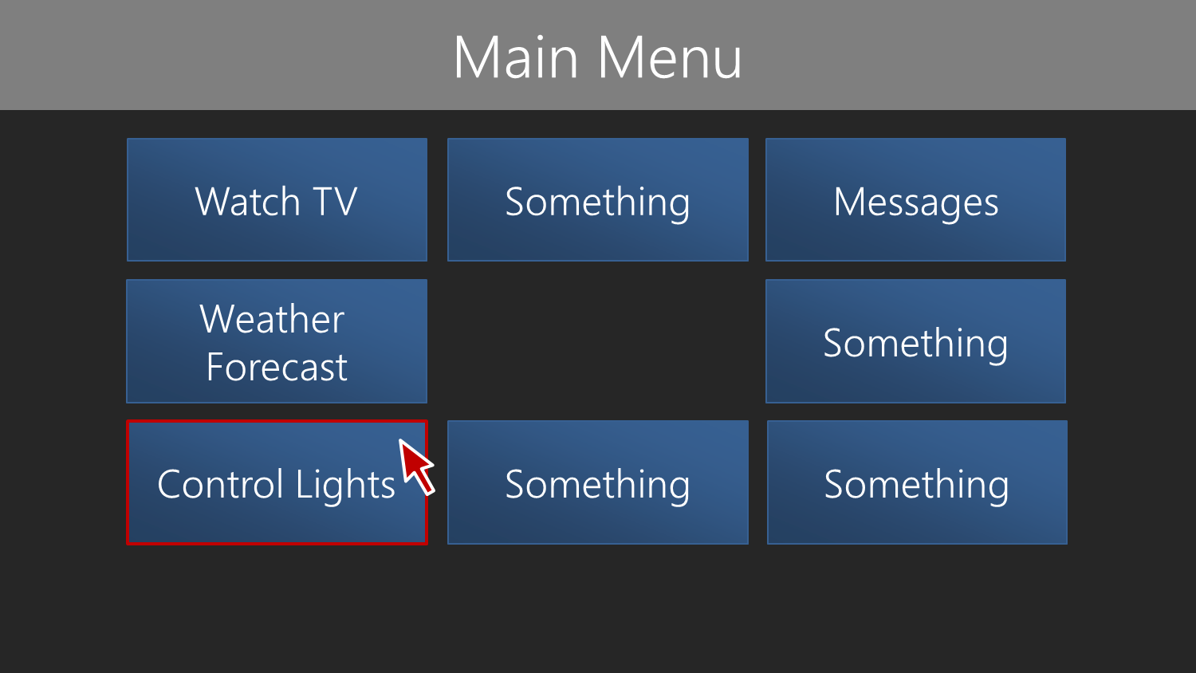

Figure 16: MyUI increased button size UI for usage with the AsTeRICS headmouse model

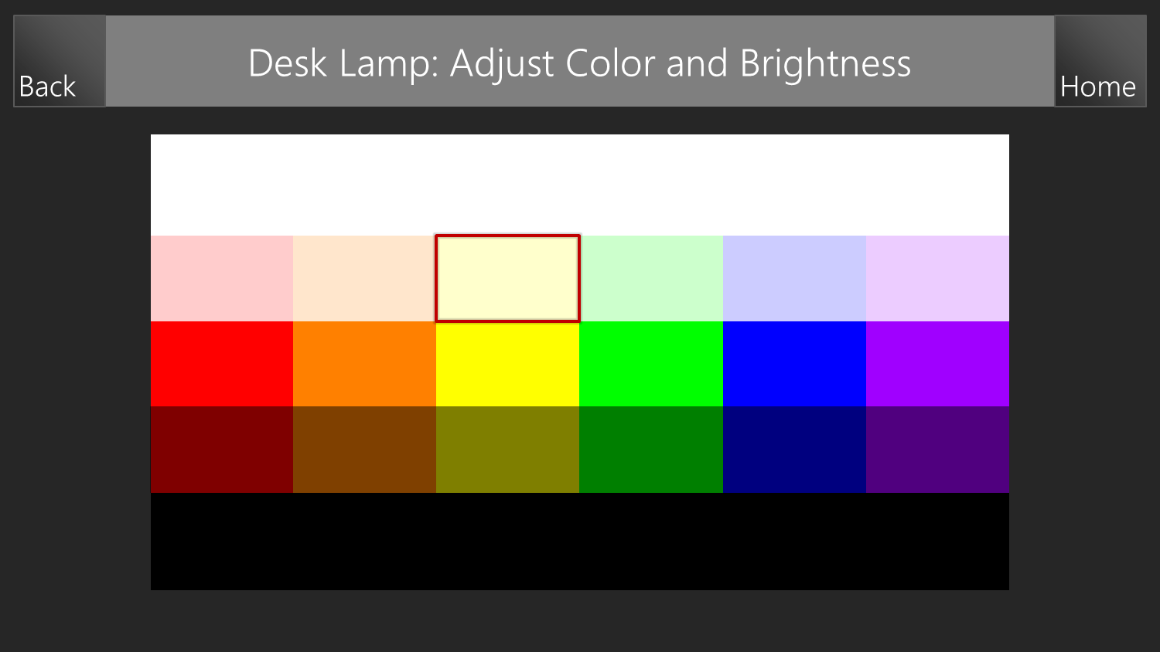

Figure 17: Mrs Moroz can change the colour of the Philips HUE light through the MyUI UI via head movements

**Scenario Part 2**

When Nicholas enters the common room, he needs to switch off the fan heater and also to change the colour of the lights to something brighter. Nicholas approaches the touch screen. The GPII, based on Nicholas’s NP (Needs Preferences), understands that due to his wheelchair, the distance between him and the control panel is increased (about 1.0m to 1.5m), so the system needs to increase the font size and also enable Scanning keyboard. MyUI will again start as a GPII “solution” with parameters “increased button size” and initiate/maintain connection with URC, while the ARE will be initiated by GPII as a solution and i. deploy and ii. start the corresponding model that utilizes the Scanning keyboard for Nicholas to use. Nicholas will then use Scanning keyboard to interact with the *increased button size UI of MyUI* to *control the remote URC actuators*: change the colour of the Philips HUE light and switch off the fan heater.

**Scenario Part 3**

When Vasili Moroz enters the common room, he approaches the touch screen and needs to adjust various settings through the device normal interface (common font size, etc.). The GPII knows Vasili Moroz’s NP (Needs Preferences) and is able to initiate MyUI and ARE as solutions to facilitate Vasili Moroz. In this case, MyUI will specify common font size, while the ARE will not start a particular actuator/sensor since one is not needed for Vasili Moroz’s case. Vasili Moroz is able to turn on the fan heater via accessing the remote URC actuator through MyUI interaction.

### MyUI → ARE → URC

In this case the MyUI Adaptive User Interface is used to manage the AsTeRICS ARE, while the ARE handles the communication with the URC remote sensors/actuators. At first AsTeRICS ARE is started by GPII, with the appropriate AsTeRICS model initiated as well according to user NPs (e.g. the headmouse model), while MyUI is also initiated by GPII according to user NPs (e.g. increased font size). Through an appropriate MyUI user interface, the user is able via a simple click of a button to change the AsTeRICS model so that to be able to handle the remote URC sensors/actuators needed by using AT. The AsTeRICS model is then able to retrieve and or push information from/to the remote URC components.

**Scenario Part 1**

As Mrs Moroz enters the common room, GPII detects her entering the room. Mrs Moroz needs to switch on the fan heater and control the lights, therefore she uses the TV set to make these changes. Based on Mrs Moroz’s NP (Needs Preferences), GPII needs to specify “increased button size” to MyUI so that Mrs Moroz is able to read characters from a distance. MyUI will start as a GPII “solution” with parameters “increased button size". Moreover, GPII starts the ARE and i. deploys and ii. starts the corresponding model responsible for the headmouse control actuator. Via the headmouse control Mrs Moroz can use head movements to interact with the increased button size UI of MyUI to change the AsTeRICS model via a simple click of a button so that she is able to handle the remote URC sensors/actuators needed by using AT. Now, Mrs Moroz can handle the remote URC sensors via head movements as follows:

* Philips HUE light: head movement changes between available colours. Keeping still for 4 seconds on a specific colour selects it. When the light is set to the desired colour, Mrs Moroz can return to the camera-mouse model with a specific head movement to continue with other tasks.
* Switch on the fan heater: mouth movement (opening) changes between “switch on” and “switch off”. When the fan heater is set to the desired state, Mrs Moroz can return to the camera-mouse model with a specific head movement to continue with other tasks.

**Scenario Part 2**

When Nicholas enters the common room, he needs to switch off the fan heater and also to change the colour of the lights to something brighter. Nicholas approaches the touch screen. The GPII, based on Nicholas’s NP (Needs Preferences), understands that due to his wheelchair, the distance between him and the control panel is increased (about 1.0m to 1.5m), so the system needs to increase the font size and also enable Scanning keyboard. MyUI will again start as a GPII “solution” with parameters “increased button size”, while the ARE will be initiated by GPII as a solution and i. deploy and ii. start the corresponding model that utilizes the Scanning keyboard for Nicholas to use. Nicholas will then use Scanning keyboard to interact with the increased button size UI of MyUI to change the AsTeRICS model via a simple click of a button so that he is able to handle the remote URC sensors/actuators needed by using AT. Now, Nicholas can handle the remote URC sensors via head movements as follows:

* Philips HUE light: head movement changes between available colours. Keeping still for 4 seconds on a specific colour selects it. When the light is set to the desired colour, Nicholas can return to the camera-mouse model with a specific head movement to continue with other tasks.
* Switch off the fan heater: mouth movement (opening) changes between “switch on” and “switch off”. When the fan heater is set to the desired state, Nicholas can return to the camera-mouse model with a specific head movement and then switch to the Scanning keyboard model to continue with other tasks.

**Scenario Part 3**

Vasili Moroz does not need AT, therefore he would prefer to control the fan heater via the MyUI interface by using the touch screen, rather than via head movements through AsTeRICS.

# References

1. GITHUB/Linux Code Repo: https://github.com/asterics/AsTeRICS/tree/linux
2. AsTeRICS EU FP7, Online: <http://www.AsTeRICS.eu/index.php?id=88>
3. The AsTeRICS Developer Manual, Online: [http://www.AsTeRICS.eu/download/DeveloperManual.pdf](http://www.asterics.eu/download/DeveloperManual.pdf)
4. AsTeRICS Deliverable D2.3: “Report on API-specification for sensors to be integrated into the AsTeRICS Personal Platform” - <https://bscw.integriert-studieren.jku.at/bscw/bscw.cgi/43571>
5. OSGi - The Dynamic Module System for Java, Online: <http://www.osgi.org/Main/HomePage>
6. AsTeRICS code (Github Repository), Online: [https://github.com/AsTeRICS/AsTeRICS](https://github.com/asterics/AsTeRICS)
7. Server-Sent Events (SSE) Support, Java Jersey, Online: <https://jersey.java.net/documentation/latest/sse.html>
8. URC Consortium: Overview of the Universal Remote Console framework, Online: <http://www.openurc.org/TR/urc-overview2.0-20130218/>
9. URC Consortium: Universal Control Hub 1.0 (ATR), Online: <http://www.openurc.org/TR/uch1.0-20131217/>
10. URC Consortium: URC-HTTP Protocol 2.0 (ATR), Online: <http://www.openurc.org/TR/urc-http-protocol2.0-20131217/>
11. URC Consortium: Is URC-HTTP RESTful?, Online: <http://www.openurc.org/TR/urc-http-protocol2.0-20131217/urc-http-restful.html>
12. ISO/IEC 24752 (Information Technology user interfaces Universal Remote Console 5 parts, 2008
13. URC Consortium: URC Technical Primer 1.0 (DRAFT), Online: <http://www.openurc.org/TR/urc-tech-primer1.0-20121022/>
14. URC Consortium:Webclient JavaScript Library, Online: <http://www.openurc.org/tools/webclient-generic-html-3.1/>
15. Peissner, Matthias, Dagmar Häbe, Doris Janssen, and Thomas Sellner. “MyUI: Generating Accessible User Interfaces from Multimodal Design Patterns.” In EICS 2012, 81–90. Copenhagen, Denmark: ACM Press, 2012. doi:10.1145/2305484.2305500.
16. MyUI Developer Documentation, Online: <http://myuidocumentation.clevercherry.com/overview/basic-conceptst>
17. Lukas Smirek, Gottfried Zimmermann, Christos Mettouris, Marios Komodromos, Achilleas Achilleos, George A. Papadopoulos, Daniel Ziegler and Michael Beigl. "Accessible Control of Distributed Devices: Supporting People with Special Needs by Providing Adaptive Interaction", *In Proceedings of the First International Conference on Universal Accessibility in the Internet of Things and Smart Environments (SMART ACCESSIBILITY 2016)*, July 24 - 28, Nice, France, 2016.
18. Prosperity4All: “Internal Report on Architecture Design and Development”, Internal Report for T203.3, D203.1
19. JmDNS java library for a zeroConf implementation:

<http://jmdns.sourceforge.net/>

1. Draft ECMA-262: ECMAScript® 2017 Language Specification. Online <https://tc39.github.io/ecma262/#sec-promise-objects>
2. Prosperity4All: Deliverable D103.1 “Foundational Design for Prosperity4All”

1. https://www.polymer-project.org/ [↑](#footnote-ref-2)